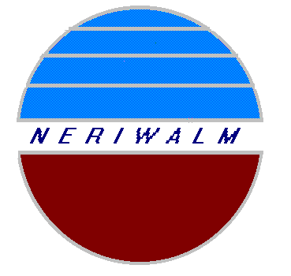
APPLICATION NO:

NORTH EASTERN REGIONAL INSTITUTE OF
WATER AND LAND MANAGEMENT (NERIWALM)

(An Institute under the Ministry of Jal Shakti, Govt. of India)
Dolabari, P.O. Kaliabhomora, Tezpur–784 027, Assam, India

Application Form for Admission: M.Tech. in Water Resource Management (approved by AICTE, affiliated to ASTU)
Session 2022-23
(To be filled in English, Put a Tick mark √ in box □ where applicable)

Photograph
(Affix a duly signed
photograph of the
candidate with)
- Name (in BLOCK LETTERS):

- Father’s Name:

- Mother’s Name:

- Address for Correspondence:

Pin code: State:

5. Permanent Address:

Pin code: State:

- Sex (Male/Female/Others):

- Category: General/OBC/SC/ST/EWS:

- Mobile No.:

- Email ID:

- Date of Birth (as per Birth Certificate/ School Leaving Certificate):dd/mm/yy

- Nationality:

- GATE Details:

Roll No. Subject: Marks obtained: Year:

13. Sponsorship Details:
Type of sponsorship: Department: Government:

14. Payment Details (DD/NEFT/Phone Pe/GPay/Paytm etc.-attach payment transfer receipt):
Transaction Number: Date:

14. Examination Passed (from 10 standard onwards) *

Examination | Board/Council/University | Institution/  College | Specialization | Year of  Passing | % Marks/  CGPA | Division/  Class

*Attach separate sheet if necessary

Enclosure Check List:

- Rs. 300.00 in the form of Demand Draft drawn in favour of “NERIWALM Self Sponsored Programme” OR NEFT OR any other form of electronic transfer of payment receipt.
- Copy of High School Leaving (10thstandard) Certificate & Marksheet
- Copies of HS (10+2 standard) Certificate & Marksheet
- Copy of BE/B.Tech/AMIE Certificate
- Candidates waiting for last semester BE/B.Tech/AMIE results will have to submit the proof of last examination passed, proof of no running backlog in the previous semester examinations and evidence of appearing in the last semester examination.
- Copy of valid GATE score card.
- Copy of the Sponsorship/No Objection Certificate issued by the employer, if the candidate is employed.
- Two passport size photograph of the candidate.

DECLARATION:

I hereby declare that the information furnished above is correct to the best of my knowledge and belief. I also agree to abide by the rules and regulations of Assam Science and Technology University.

Place:
Date: Signature of the Applicant

